|  |
| --- |
|  |
| 新概念 3 册 |
| Lesson25 The Cutty Sark |

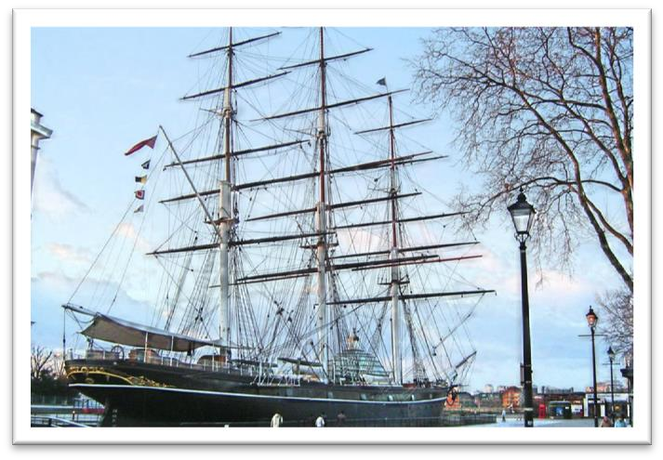（实物图）

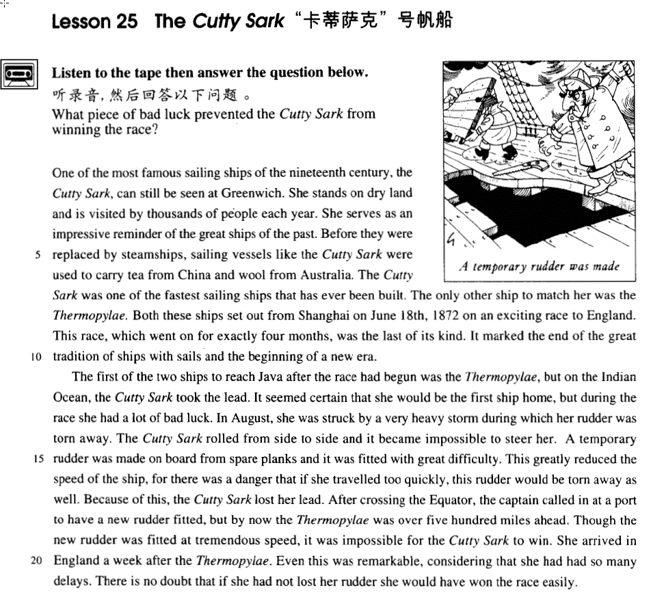

课文

One of the most famous sailing ships of the 19th century, the Cutty Sark, can still be seen at Greenwich.

人们在格林威治仍可看到19世纪最有名的帆船之一“卡蒂萨克”号。

She stands on dry land and is visited by thousands of people each year.

它停在陆地上，每年接待成千上万的参观者。

She serves as an impressive reminder of the great ships of the past.

它给人们留下深刻的印象，使人们回忆起历史上的巨型帆船，

Before they were replaced by steamships, sailing vessels like the Cutty Sark were used to carry tea from China and wool from Australia.

在蒸汽船取代帆船之前。“卡蒂萨克”号之类的帆船被用来从中国运回茶叶，从澳大利亚运回羊毛。

The Cutty Sark was one of the fastest sailing ships that has ever been built.

“卡蒂萨克”号是帆船制造史上建造的最快的一艘帆船。

The only other ship to match her was the Thermopylae.

唯一可以与之一比高低的是“塞姆皮雷”号帆船。

Both these ships set out from Shanghai on June 18th, 1872 on an exciting race to England.

两船于1872年6月18日同时从上海启航驶往英国，途中展开了一场激烈的比赛。

This race, which went on for exactly four months, was the last of its kind.

这场比赛持续了整整4个月，是这类比赛中的最后一次，

It marked the end of the great tradition of ships with sails and the beginning of a new era.

它标志着帆船伟大传统的结束与一个新纪元的开始。

The first of the two ships to reach Java after the race had begun was the Thermopylae, but on the Indian Ocean, the Cutty Sark took the lead.

比赛开始后，“赛姆皮雷”号率先抵达爪哇岛。但在印度洋上，“卡萨萨克”号驶到了前面。

It seemed certain that she would be the first ship home, but during the race she had a lot of bad luck.

看来，它首先返抵英国是确信无疑的了，但它却在比赛中连遭厄运。

In August, she was struck by a very heavy storm during which her rudder was torn away.

8月份“卡蒂萨克”号遭到一场特大风暴的袭击，失去了一只舵。

The Cutty Sark rolled from side to side and it became impossible to steer her.

船身左右摇晃，无法操纵。

A temporary rudder was made on board from spare planks and it was fitted with great difficulty.

船员用备用的木板在船上赶制了一只应急用的舵，并克服重重困难将舵安装就位，

This greatly reduced the speed of the ship, for there was a danger that if she travelled too quickly, this rudder would be torn away as well.

这样一来，大大降低了船的航速。因为船不能开得太快，否则就有危险，应急舵也会被刮走。

Because of this, the Cutty Sark lost her lead.

因为这个缘故，“卡蒂萨克”号落到了后面。

After crossing the Equator, the captain called in at a port to have a new rudder fitted, but by now the Thermopylae was over five hundred miles ahead.

跨越赤道后，船长将船停靠在一个港口，在那儿换了一只舵。但此时，“赛姆皮雷”号早已在500多英里之遥了。

Though the new rudder was fitted at tremendous speed, it was impossible for the Cutty Sark to win.

尽管换装新舵时分秒必争，但“卡蒂萨克”号已经不可能取胜了，

She arrived in England a week after the Thermopylae. Even this was remarkable, considering that she had had so many delays.

它抵达英国时比“塞姆皮雷”号晚了1个星期。但考虑到路上的多次耽搁，这个成绩也已很不容易了。

There is no doubt that if she had not lost her rudder she would have won the race easily.

毫无疑问，如果中途没有失去舵， “卡帝萨克”号肯定能在比赛中轻易夺冠。

词汇讲解

* **impressive** [ɪm'presɪv] adj. (褒义)给人以深刻印象的
* an **impressive** （做定语）ceremony / building / speech / performance …
* The girl was very **impressive**（做表语） in the interview.

**impress sb. with / by sth.** 后面的事给前面的人留下了深刻的印象

* The girl **impressed** her fiancé's family with her liveliness and sense of humor.
* We were most **impressed** **with** **/** **by** your efficiency.
* I had no intention of buying one, but I could not conceal the fact that I was **impressed by** the size of the diamonds.

**give sb. the impression that …** 使某人觉得…

* The sudden movement of the door made it sway slightly and it **gave me the impression that** it was about to leap out at me.

**have / get the impression that …** 有…这种感觉

* I **had the distinct impression that** I was being followed.

**be under the impression that ...** 某人误以为…

* Though the crew **were** at first **under the impression that** the lost ship had been found, the contents of the chest proved them wrong.
* **era** ['ɪərə]n. 时代，时期

**era / epoch** 重大的历史时期

* the Victorian / Clinton **era** / **epoch** 维多利亚/克林顿 时期
* the steam-engine / post-war **era** / **epoch** 蒸汽机/战后顿时期
* We live in an **era** / **epoch** of breathtaking change.

**the beginning / dawn / dawning of a new era / epoch**

**be on the threshold of a new era / epoch** 新时代的开始

**the end of an era / epoch**时代的结束

* It marked the end of the great tradition of ships with sails and the beginning of a new era.
* His death marked **the end of an era**.
* in modern / recent / ancient / prehistoric times 历史时期

**in times of …** 在…时期

* in times of peace / war
* **In times of peace**, when business was bad, Hawkwood and his men would march into a city-state …

**age** 时代、时期

* the Bronze / Ice / Stone Age 历史时期
* the modern / computer age 历史时期
* **In this age of** the Internet, finding a job can be much easier.
* The nomads who made these markings lived by hunting and fishing during **the last Ice Age**, which began about 35,000 B.C. and ended about 10,000 B.C.
* **rudder** ['rʌdə(r)]n. 舵

**rudder** 舵

**anchor** 锚

**mast** 桅杆

**deck** 甲板

**hull** 船体

**cabin** 船舱

**bow** 船头

**stern** 船尾

**port** 左舷

**starboard** 右舷

* **roll** [rəʊl] v. 滚动；卷起；摇摆； 发出隆隆声
* Tears **rolled**（滚动） down her cheeks.
* The ball **rolled**（滚动） down the hill.
* **rolling**（滚动） stone
* a **rolling**（滚动） stone gathers no moss
* George took off his jacket, **rolled** up(卷起) his sleeves and pushed his right arm through the drain cover.
* The ship was **rolling**(v.摇摆) heavily to and fro.
* The Cutty Sark **rolled**(v.摇摆) from side to side and it became impossible to steer her.
* Thunder **rolled** in the distance.

**a roll of** carpet / film / cloth **一卷**

* spring **roll** 春卷
* The teacher called the **roll**(花名册).
* Three senators missed the **roll** (花名册) call.
* The slow, steady **roll**(n.摇摆) of the ship made us feel sick.
* the distant **roll**(n.摇摆) of thunder
* **steer** [stɪə(r)] v. 驾驶 (没有场合限制)
* This car is very easy to **steer**.
* He **steered** the boat into the harbor.

**drive** (只能是陆地上交通工具)

* Can you **drive**?
* He **drives** a taxi.

**ride** (只能是两个轮子的)

* I **ride** a bicycle to work every day.

**pilot**(只能是轮船和飞机)

* The captain **piloted** the boat into a mooring.
* She **piloted** the aircraft to safety after one of the engines failed.

**fly**(只能是飞机)

* Only experienced pilots **fly** large passenger aircraft.

**be at / behind the wheel** (只能是汽车) 在驾驶室里

* Who **was at the wheel** when the car crashed?
* One man stayed **at the wheel** while two others with black stockings over their faces jumped out and smashed the window of the shop with iron bars.
* **temporary** ['temprəri] adj. 临时的，暂时的，非永久的
* a **temporary** job
* a **temporary** measure
* **temporary** relief from pain

**temporarily**

* She's only working here **temporarily**.
* Only an **exceptionally** heavy snowfall might temporarily dislocate railway services.

**permanent** ***adj.*** 永久的，永恒的；不变的

* a **permanent** job
* my **permanent** address
* My cousin, Harry, keeps a large curiously shaped bottle on **permanent** display in his study.

**permanently** ***adv.*** 永久地，长期不变地

* She had decided to settle **permanently** in France.

**provisional *adj.*** 临时的，暂时的；暂定的

* a **provisional** government

**provisionally *adv.*** 临时地，暂时地

* The meeting has been **provisionally** arranged for 3 p.m. next Friday.

**contemporary *adj.*** 当代的；同时代的；属于同一时期的 ***n.*** 同时代的人；同时期的东西

* **contemporary** music / art / dance



* Marlowe was **contemporary** with Shakespeare.
* Marlowe and Shakespeare were **contemporaries**.
* **fit [fɪt]** v. 安装；适合

**fit sth. on / to sth.** 把…安装到…

* I need to **fit** a lock **on** the bathroom door.
* Anti-theft devices are **fitted** **to** all our cars.

**be fitted with sth 被安装上了…**

* The windows and doors **are all fitted with** security locks.
* It has to be tall because it is like a giant block and tackle, and we have to lower into the ground and haul out of the ground great lengths of drill pipe which are rotated by an engine at the top and **are fitted with** a cutting bit at the bottom.
* The uniform **fitted**（适合） her perfectly .
* The punishment should **fit**（适合） the crime.
* This card just **fits**（刚刚好） nicely into that envelope.
* I was not surprised to find that the machine still refused to work after I had reassembled it, for the simple reason that I was left with several curiously shaped bits of metal which did not seem to **fit**（刚刚好） anywhere.
* I swim twice a week to try and keep **fit**（健康）.

**be fit for** 适合某事，（一般用于否定）

**be fit to do sth** 适合做某事 （一般用于否定）

* This book **is** not **fit for** publication!
* He **is** not **fit to** govern this country!
* But Alfred had deduced that the Danes **were** no longer **fit for** prolonged battle: …
* Chickens slaughtered in the United States, claim officials in Brussels, **are** not **fit to** grace European tables.
* **delay** [dɪ'leɪ] v. & n. 耽搁；推迟，延期
* We must leave without **delay**(此处做不可数名词).
* There was a **delay** of two hours before the plane took off.
* You’ll be late if you **delay**（不及物）.
* I was **delayed**（及物） by the traffic.

**delay / postpone sth. until …** （及物）把某事推迟到某个时刻

* The match had to be **delayed / postponed** **until** **next week.**

**delay / postpone sth. for …** 推迟了多长时间

* Our meeting was **delayed** / **postponed** **for** **ten minutes**.

**delay / postpone doing sth.** 推迟做某事

* It was an unpopular decision to **delay** / **postpone** **building** the new hospital.

**bring / put sth. ⇔ forward to …** 提前…到什么时候

* The meeting has been **brought** / **put** **forward** **to** **Thursday**.

课文讲解

# （第一段）

# One of the most famous sailing ships of the 19th century, the Cutty Sark, can still be seen at Greenwich.

One of the most famous sailing ships of the 19th century,（主语） the Cutty Sark（主语的同位语）, can still be seen at Greenwich.

知识点（一）

**One of the most…** 最…之一

知识点（二）

表达“世纪”：

**in the** **early / middle / late** 19th **century**

**at the** **turn(初) / dawn / beginning of the** 19th **century** （时间短的用at）

**at the end of the** 19th **century** …世纪末期

知识点（三）

**语法：**表达“船只”前加定冠词，做同位语可省略

The loss of the Titanic

the Cutty Sark

the Vasa

* The great ship, Titanic, sailed for New York from Southampton on April 10th, 1912.
* The small ship, Elkor, which had been searching the Barents Sea for weeks, was on its way home.
* One of the most famous sailing ships of the 19th century, **the** Cutty Sark, can still be seen at Greenwich.

知识点（四）

Greenwich：格林威治（英国伦敦东南一市镇， 从前皇家天文台的所在地； 通过该天文台的经线被定为本初子午线）

GMT: Greenwich Mean Time 世界标准时

# She stands on dry land and is visited by thousands of people each year.

**语法：指“车、船、祖国”时常用 “she”**

* **She** was carrying 1,316 passengers and crew of 891.
* What’s wrong with my car? **She** won’t start.
* China has done what **she** promised to do.

# She serves as an impressive reminder of the great ships of the past.

知识点（一）

**serve as …** 发挥…作用/当做…来用

* This room can **serve as** a study.
* Her death should **serve as** a warning to other young people.
* Not all sounds made by animals **serve as** language, …

**act as …** 发挥…作用/当做…来用

**function as …** 发挥…作用/当做…来用

* A five-year sentence should **act as** a deterrent to others.
* Some English adverbs **function as** adjectives.

知识点（二）

**reminder** (**souvenir** 、**memo** …) 使人回忆起其他事物的物品

* Alison's story is a **reminder**（提醒物） of how vulnerable women can be in what is still essentially a man's world.

知识点（三）

**serve / act as a reminder** = **be a reminder** 使人们回忆起

* The drop in stock prices **serves / acts as a reminder** that investing is a form of gambling.
* The accident **served / acted as a timely reminder** of just how dangerous speeding can be.

# Before they were replaced by steamships, sailing vessels like the Cutty Sark were used to carry tea from China and wool from Australia.

Before they were replaced by steam-ships（时间状语从句）, sailing vessels *like the Cutty Sark（后置定语修饰“帆船”，like做介词）* were used to carry tea from China and wool from Australia.（并列宾语）

知识点（一）

**replace** ***vt.*** 取代，代替；替换，更换；归还，偿还；把…放回原处

* Robots are **replacing** people on assembly lines.

**be replaced by …** 被…取代

* Before they **were replaced by** steam-ships, sailing vessels like the Cutty Sark were used to carry tea from China and wool from Australia.
* The old farmhouse the family lived in was to **be replaced by** a new $500,000 home.

知识点（二）

**steamship** ***n.*** 轮船；汽船

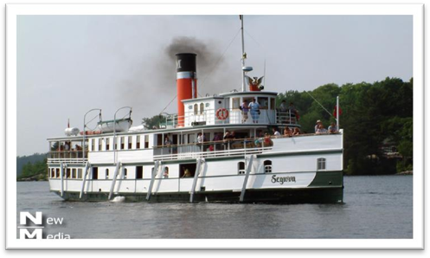

**sailing ships** 帆船

**sailing vessels** 帆船

**ships with sails** 帆船

知识点（三）

**be used to do** 被用来做某事

**be used to doing** 习惯做某事

**used to do** 过去常做

# The Cutty Sark was one of the fastest sailing ships that has ever been built.

知识点（一）

…that （主语）has ever been built.

**语法**：定语从句先行词前有形容词最高级修饰，后面关系代词不用（which, who, whom…）,而用that

* At that time, however, she was not only *the largest ship* **that** had ever been built, but was regarded as unsinkable, for she had 16 watertight compartments.

知识点（二）

**语法：**one of + 复数名词 + who / which / that + 谓语动词（单复数均可），如果one前面有定冠词the限定，定语从句的谓语动词用单数。

* The Cutty Sark was one of the fastest sailing ships that ***has***ever been built.
* One of the things that ***fascinates***us most about cats is the popular belief that they have nine lives.
* Jasper White is one of those rare people who ***believes***in ancient myths.
* **托福改错题：**
* John is *the* only *one* of the students in the class (A) that never (B) admit making a mistake even when (C) it is (D) pointed out to him.
* John is *the* only *one* of the students in the class that never admits making a mistake even when it is pointed out to him.

# The only other ship to match her was the Thermopylae.

课文分析

The only other ship to match her（后置定语，限定other ship） was the Thermopylae.

**match** v. 与……相匹敌，是……的对手

* No one can **match** the unknown archer.
* The two teams are well **matched**.

**match … in / for …** 在…与某人匹敌

* You can’t **match** him **in** knowledge of wild plants.
* But nothing can **match** them **for** speed and comfort.
* The hotel can’t be **matched** **for** good service and food.

# Both these ships set out from Shanghai on June 18th, 1872 on an exciting race to England.

Both these ships set out *from Shanghai（地点状语）* on June 18th, 1872 （时间状语）*on an exciting race to England.（目的状语）*

知识点（一）

**set out / off** 动身出发，不强调方式

**start out / off**

* Four days after **setting out**, while the Titanic was sailing across the icy waters of the North Atlantic, a huge iceberg was suddenly spotted by a look-out.
* After making a short test flight at 4.15 a.m., Bleriot **set off** half an hour later.
* One afternoon she **set out** from the coast in a small boat and was caught in a storm.
* She is going to **set out** from the French coast at five o'clock in the morning.
* Dressed up as Father Christmas and accompanied by a 'guard of honour' of six pretty girls, he **set off** down the main street of the city riding a baby elephant called Jumbo.

**set out to do** 带着目的去做某事

* The journalist immediately **set out to obtain** these important facts, but he took a long time to send them.
* Dimitri at once **set out to find** the thief.
* True eccentrics never deliberately **set out to draw** attention to themselves.

知识点（二）

介词**on**: 在…的路上

* Several people complained of ‘cat-like noises’ at night and a businessman **on** a fishing trip saw the puma up a tree.
* While **on** a walking tour with his wife, he stopped to talk to a workman.

介词**on**：和动作的词连用，表示开始做某事

* Both these ships **set out** from Shanghai on June 18th, 1872 **on** an exciting race to England.
* We **started** out **on** a 20-mile walk.
* She had **come** **on** a visit to England.
* After a day or so we will **go** **on** an excursion.

# This race, which went on for exactly four months, was the last of its kind.

This race, which went on for exactly four months(定语从句，修饰race), was the last of its kind.

**go on** （单独使用）持续，延续

* Peace negotiations are still **going on**.
* His speech **went on** for so long that people began to fall asleep.

**go on with sth.** 继续做同样的时

**go on to do** 继续做下一件事

**go on doing** 不同的做

# It marked the end of the great tradition of ships with sails and the beginning of a new era.

It marked the end of the great tradition of ships with sails and the beginning of a new era. （并列宾语）

**the beginning / dawn / dawning of a new era / epoch** 新时代的开始

* The race was a landmark **in the history of** shipping.
* **课后题：**
* 2. The race which took place between the Cutty Sark and the Thermopylae was ___A___.

(a) a landmark in the history of shipping

(b) held to celebrate the invention of the steamship

(c) held especially for sailing ships on the route from Shanghai to London

(d) unusually slow because the Cutty Sark lost her rudder en route

# （第二段）

# The first of the two ships to reach Java after the race had begun was the Thermopylae, but on the Indian Ocean, the Cutty Sark took the lead.

The first of the two ships（主语） *to reach Java （后置定语）*after the race had begun （时间状语）was the Thermopylae, but （并列句）on the Indian Ocean, the Cutty Sark took the lead.

知识点（一）

The first of the two ships to reach Java / **that reached Java** after the race had begun was …

**语法**：the first, the second, the next, the last, the best, the only … 后常跟不定式作后置定语。

* When he landed near Dover, **the first** person **to** greet him was a local policeman.
* The Swedes were **the first** **to** recognize that public officials like civil servants, police officers, health inspectors or tax-collectors can make mistakes or act over-zealously in the belief that they are serving the public.
* You are **the second to** ask me that question.
* **The next** man **to** approach me was selling expensive pens and watches.
* **The last** creature **to** compete with man was the mosquito.
* The pie committee decided that **the best** way **to** transport the dish would be by canal, so they insured it for the trip.
* **The only** other ship **to** match her was the Thermopylae.

知识点（二）

… **after** (连词)the race had begun …

* 课文写法替换写法:
* The first of the two ships to reach Java **after**（介词） the beginning of the race was the Thermopylae,

知识点（三）

**the lead** 比赛中的领先地位

**take (over) the lead (from …)** 夺取了领先地位

**lose the lead (to …)** 丧失领先地位

* 课文写法替换写法:
* …, but on the Indian Ocean, the Cutty Sark **took (over) the lead from the Thermopylae**.
* …, but on the Indian Ocean, the Thermopylae **lost the lead to the Cutty Sark**.
* Because of this, the Cutty Sark **lost her lead**.

**be in the lead** 处于领先地位

**go / move into the lead** 进入领先位置

* She was **in the lead** from start to finish（从头至尾）.
* With a final burst of speed she **went / moved into the lead**.

# It seemed certain that she would be the first ship home, but during the race she had a lot of bad luck.

*It* seemed certain *that she would be the first ship home*（主语）, but *during the race* she had a lot of bad luck.

知识点（一）

表达“看似…是肯定/好像的，但是…”

**It looked / seemed / appeared certain that …, but …**

**It looked / seemed / appeared *as if / as though* …, but …**

* 课文写法替换写法:
* **It looked / seemed / appeared *as if / as though*** she would be the first ship home, but during the race she had a lot of bad luck.
* **造句**：看似肯定会有一场激动人心的穿越海峡的竞速比赛了，但是莱瑟姆未能起得足够早。
* **It looked / seemed / appeared certain that** there would be an exciting race across the Channel, but Latham failed to get up early enough.
* **造句**：看似好像会有一场激动人心的穿越海峡的竞速比赛了，但是莱瑟姆未能起得足够早。
* **It looked / seemed / appeared *as if / as though***there would be an exciting race across the Channel, but Latham failed to get up early enough.

知识点（二）

**luck** 不可数

* It was **an** incredible **piece of luck**.
* With **a bit of luck**, we'll finish on time.
* Often there is **an element of luck** in getting the right answer.

**bad / ill / rotten / tough luck** 坏运气

* The team has had **a run of bad luck** lately(坏运气), losing their last five games.

# In August, she was struck by a very heavy storm during which her rudder was torn away.

知识点（一）

**strike** (struck struck)

***n.*** 罢工；打击；殴打

***vi.*** 打，打击；罢工；敲，敲击；抓；打动；穿透

***vt.*** 打，击；罢工；撞击，冲击；侵袭；打动；到达

* The big clock which used to strike（打） the hours day and night was damaged many years ago and has been silent ever since.
* One of the thieves was struck （砸）by a heavy statue, but he was too busy helping himself to diamonds to notice any pain.

**it strikes sb. that …** 某人想到某事

* **It suddenly struck Mrs. Richards that** it must be the man from the Electricity Board who had come to read the meter.

本文中struck本文中表示“不幸的事情突然发生，而且造成严重后果”

* Most people were fast asleep when the earthquake **struck**.

**be caught in …** 遭受倒霉的事情

* We were caught in **a heavy storm / a traffic jam.**

知识点（二）

**heavy / severe / violent / devastating / disastrous storm** 严重的暴风雨

知识点（三）

语法：简化定语从句during which

* In August, she was struck by a very heavy storm and during the storm her rudder was torn away. 不地道写法
* In August, she was struck by a very heavy storm **during which** her rudder was torn away.
* A week before, he had completed a successful overland flight **during which** he covered twenty-six miles.

知识点（三）

**tear sth. away / off / up …** 撕扯掉

* The flag was **torn away** from the pole by the strong wind.
* High winds nearly **tore the roof off**.
* The storm had **torn** the old tree up by the roots.

# The Cutty Sark rolled from side to side and it became impossible to steer her.

**roll heavily / violently *from side to side （左右）/ to and fro（前后 ）***剧烈摆动

* The ship was **rolling heavily to and fro**.
* The plane **rolled violently from side to side** in the storm.

**from side to side**

* His few material possessions make it possible for him to move **from place to place** （四处）with ease.

read sth. **from cover to cover**从头到尾

sell sth. **from door to door** 挨家挨户

vary f**rom person to person** 因人而异

improve **from day to day**日益

# A temporary rudder was made on board from spare planks and it was fitted with great difficulty.

知识点（一）

**on board** 在船上

* Before she had anchored, the men from the boats had climbed **on board**（到船上） and the decks were soon covered with colourful rugs from Persia, silks from India, copper coffee pots, and beautiful hand-made silver-ware.

**spare** 备用

a spare key / battery / tire …

知识点（二）

A temporary rudder was made on board from spare planks and it was fitted **with great difficulty** (=**very difficultly**).

* The Officer went through the case with great care (=very carefully).

# This greatly reduced the speed of the ship, for there was a danger that if she travelled too quickly, this rudder would be torn away as well.

This greatly reduced the speed of the ship (主句), for（从句原因状语con） there was a danger *that（danger的同位语） if （条件状语）she travelled too quickly, this rudder would be torn away as well*.

**there is / was a danger that …** 某个不好的事情会发生

* **There was a danger that** the wave would rebound off the other side of the bank and send the dish plunging into the water again.
* **There is a danger that** the political disorder of the past will return.
* **There is a danger that** museums will attempt to entertain rather than educate.
* **造句**：如果 Ramsay 夫人报警，她可能就再也看不到 Rastus 了。
* There was a danger that if Mrs. Ramsay went to the police, she would never see Rastus again.

# Because of this, the Cutty Sark lost her lead.

* **课文替换写法：**
* Because of this, the Cutty Sark lost her / the lead to the Thermopylae.
* Because of this, the Thermopylae took (over) the lead from the Cutty Sark.

# After crossing the Equator, the captain called in at a port to have a new rudder fitted, but by now the Thermopylae was over five hundred miles ahead.

After crossing the equator（时间状语从句）, the captain called in at a port *to have a new rudder fitted（目的状语）*, but （并列句）*by now* the Thermopylae was over 500 miles ahead.

知识点（一）

**equator** ***n.*** 赤道

**pole *n.*** (地球的)极，磁极

**the North / South Pole** 北极/南极

**latitude *n.*** 纬度；界限；活动范围

**longitude *n.*** [地理] 经度；经线

**axis *n.*** 轴；轴线；轴心国

知识点（二）

**call in at somewhere** 顺路去某个地方

**call in on sb.** 顺路拜访某人

* Will you **call in at** the supermarket for some eggs and milk?
* Could you **call in on** Mum on your way home?

知识点（三）

by now = by then

* I had expected to be near my objective **by now**, but everything still seemed alien to me.

知识点（四）

…, but by now the Thermopylae was over 500 miles **ahead (of the Cutty Sark / her).**

# Though the new rudder was fitted at tremendous speed, it was impossible for the Cutty Sark to win.

Though the new rudder was fitted at tremendous speed（让步状语从句）, it（形式主语） was impossible for the Cutty Sark to win（真正主语）.

知识点（一）

表达“以…速度…”

**1.speed 做不可数名词时，与 at, with 搭配均可**

* at / with great speed

**2.speed 做可数名词时，只能与 at 搭配**

* at a speed of 60 mph

知识点（二）

**tremendous** ***adj.*** 极大的，巨大的；惊人的；极好的

* In his day, Mendoza enjoyed **tremendous** popularity.

**at tremendous speed**

**at (a) fantastic speed**

# She arrived in England a week after the Thermopylae. Even this was remarkable, considering that she had had so many delays.

知识点（一）

时间表达：

* **Four days** **after** setting out, while the Titanic …
* **Three days after** Rastus' disappearance, Mrs. Ramsay received an anonymous letter.
* A man who had broken his right leg was taken to hospital **a few weeks before** Christmas.

知识点（二）

**considering** prep. & conj. 考虑到

* **Considering** （介词）the amount she paid, he was dear in more ways than one!
* Even this was remarkable, **considering**（复合连词） (that) she had had so many delays.

# There is no doubt that if she had not lost her rudder she would have won the race easily.

There is no doubt that *if she had not lost her rudder* she would have won the race easily.

知识点（一）

**there is no doubt that …** 毫无疑问

* **There's no doubt that** one day a cure will be found.

**undoubtedly** 毫无疑问

* She was **undoubtedly** the best candidate.
* **Undoubtedly**, public interest in folk music has declined.

**needless to say, …** 毫无疑问

* **Needless to say**, the man's name was Hans Bussman and he really was Franz's long-lost brother.
* **Needless to say**, the bigger the risk an insurance company takes, the higher the premium you will have to pay.

**it goes without saying that …** 不用说（毫无疑问）

* **It goes without saying that** home is the warmest place in the world.
* **It goes without saying that** a real sportsman will never dream of cheating in a game.

知识点（二）

**语法：**与过去事实相反的“if”型的虚拟

**If + S. + had done, S. + would / should / could / might + have done**

* If they **had** only **had** one more child, the fact ***would have passed***unnoticed.
* If the Houses of Parliament **had not been** burned down in 1834, the great clock ***would never have been erected*.**
* ~~… she would have won the Thermopylae easily.~~ X 错误表达
* … she would have beaten / defeated the Thermopylae easily. √
* **造句**：毫无疑问，如果泰坦尼克号没有撞到冰山，她将抵达目的地而毫发无伤 (intact)
* There is no doubt that if the Titanic had not been hit by the iceberg, she would have reached her destination intact.